Crypt-Arithmetic Problem

Aim
To implement a Crypt-Arithmetic problem using Python.
Objective
To assign unique digits to different letters so that the given arithmetic equation is mathematically correct.
Algorithm
- Start the program.
- Read the first word, second word, and result word.
- Find all unique letters.
- Assign digits (0–9) to letters one by one.
- Ensure no two letters have the same digit.
- Do not assign 0 to the first letter of any word.
- Check whether the formed numbers satisfy the equation.
- If the equation is correct, display the solution.
- Otherwise, backtrack and try another digit assignment.
- Stop the program.

Flowchart
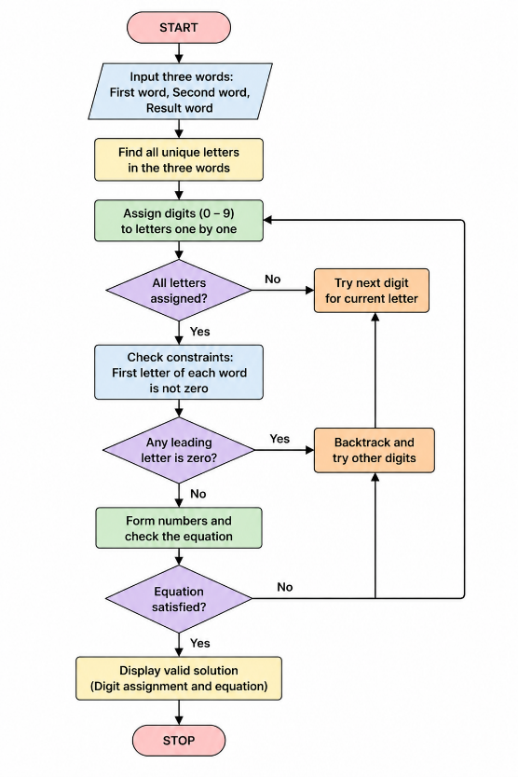

Python code
from itertools import permutations

word1 = input("Enter first word: ").upper()
word2 = input("Enter second word: ").upper()
result = input("Enter result word: ").upper()

letters = []

for ch in word1 + word2 + result:
if ch not in letters:
letters.append(ch)

first = {word1[0], word2[0], result[0]}

def number(word, mapping):
return int("".join(str(mapping[c]) for c in word))

found = False

for perm in permutations(range(10), len(letters)):
mapping = dict(zip(letters, perm))

valid = True
for ch in first:
if mapping[ch] == 0:
valid = False
break

if not valid:
continue

if number(word1, mapping) + number(word2, mapping) == number(result, mapping):
print("\nSolution Found")
print(mapping)
print(number(word1, mapping), "+",
number(word2, mapping), "=",
number(result, mapping))
found = True
break

if not found:
print("No Solution Found")
OUTPUT
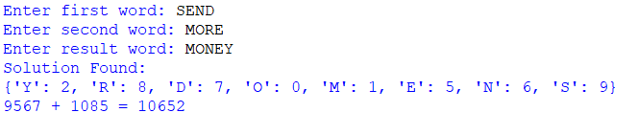
Result
The Crypt-Arithmetic problem was successfully solved by assigning unique digits to each letter.
Conclusion
The program successfully finds a valid digit assignment for the given Crypt-Arithmetic puzzle using permutation and constraint checking.

